

**CST3990**

**Individual Project**

**Module Leader: Fehmida Hussain**

**Project Supervisor: Sumitra Kotipalli**

**Student Name: - Neville Mathew**

**MISIS: - M00693517**

Contents

List of Tables 3

Table of Figures 3

Abstract 4

Introduction 5

Literature Review 7

Effects of COVID-19 & Air Travel 7

Analysis of Existing Projects 10

Requirements 11

Hardware Requirements 11

Software Requirements 11

System Analysis & Design 12

Project Management Methodologies 13

Kanban Workflow 14

References 15

List of Tables:

Table 1: Existing Projects 10

Table 2: Project Methodologies 13

Table of Figures:

Figure 1: Aviation Industry 5

Figure 2: Global Employment & GDP Impact 6

Figure 3: IATA Statistics 8

Figure 4: FlightRadar24 Statistics 9

Figure 5: Wireframes 12

Figure 7: Trello 14

# Abstract

Aeroplanes have been an important part of society since the time air travel began. It helped people reach their destinations at a reasonable cost and at the right time. The advancements in technology has helped increase the efficiency and effectiveness of aeroplanes. From improved pilot navigation systems to understanding flight paths/patterns, the air travel industry has proven itself countless times on how it facilitates economic growth and international trade.

COVID-19 has provided a lot of challenges and hoops for the aviation industry to overcome. According to experts, it is stated that the airline industry will not completely recover by 2022. The answer or result of where the aviation industry will reach is unpredictable.

This paper provides an understanding or review as to how COVID-19 has greatly impacted the airline industry and where it may go from there.

# Introduction

Since the beginning of COVID-19, many airline companies were in losses or completely shut down, the main issue was of how many pilots lost their job as a result of this. This project will involve the use of qualitative data to show how airlines have been affected by this pandemic situation. Due to the increase of technological devices, there has also been an influx of data being generated through the years. There are about 2.5 quintillion bytes of data which is generated by humans every day, this is about 90% of the world’s data increase from the last two years alone (Marr, 2020). However, an exception can be made for the aviation industry where airline data has drastically reduced through mid-2019 to 2020.

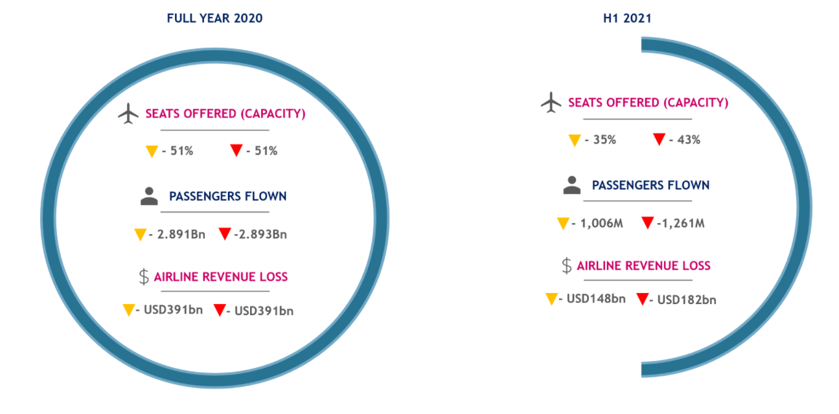This pandemic has caused the air travel industry and various other airline companies to go bankrupt or cut down on employee benefits, salaries etc. Throughout the year 2020, the airline industry has lost a total of $391 billion. This shows how impactful COVID-19 is to airline companies. Predicting or understanding how bad the loss is to reach will help airline companies be prepared for what is to come. Although, predictions can’t always be accurate, sometimes it can be detrimental. The figure below shows a deeper understanding of the impact of COVID-19 on the aviation industry for the full year and the first quarter as well. (Economic Impacts of COVID-19 on Civil Aviation, 2021)

Figure : Aviation Industry

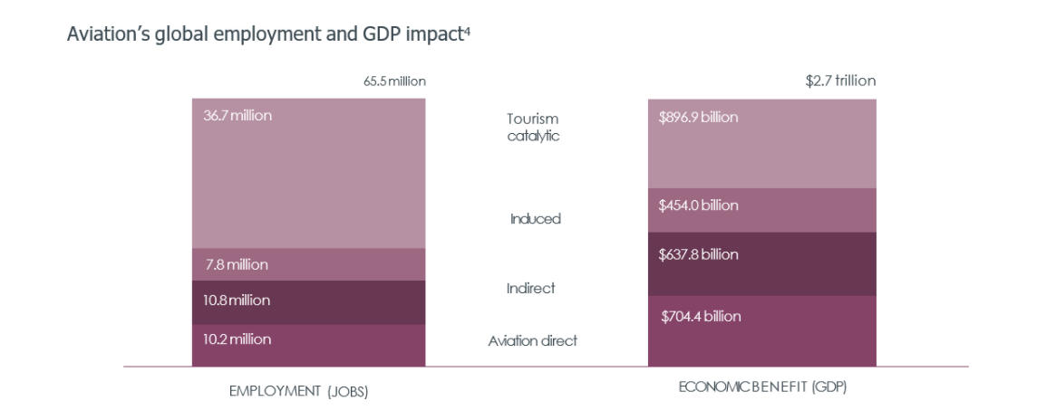COVID-19 has impacted many industries, sectors and especially employees working in those affected industries, in this case, the aviation industry. Airlines are key towards worldwide transportation, through generating economic growth, international trade and tourism. The economic context of the airline industry is based on a total support of 65.5 million employees globally. (Economic Impacts of COVID-19 on Civil Aviation, 2021). This figure does not just signify normal airline travel or services but also the civil aerospace sector which comes under manufacturing of systems, engines and general maintenance, indirect and direct jobs related to tourism companies.

Figure : Global Employment & GDP Impact

Aside from the employment aspect, the basic GDP impact on countries is severe, the airline industry doesn’t just boost in economic growth of the country but helps in other aspects such as decreasing poverty. According to analyst forecasts, both air passenger and freight traffic is to more than double by 2036, which will generate over $5.7 trillion in GDP. (Economic Impacts of COVID-19 on Civil Aviation, 2021)

The **objective** of this research study is to analyse or study the literature based on how COVID-19 and the air travel industry has been affected during the year 2019-2020. The study will include, understanding previous research done on the topic such as going through notebooks on Kaggle, papers, graphs etc. This will be greatly helpful on how to start the final report and what structure to be followed.

# Literature Review

Effects of COVID-19 & Air Travel**:**

The coronavirus began in December 2019, where the first human cases were reported in Wuhan City, China. The source for this virus started from the Huanan seafood market which were reported to have the most cases. From a current paper, it shown that animals were the first to contract this virus, bats and snakes were known to be the repositories of this virus. It was previously called SARS-CoV-2. Coronavirus is an infectious disease which has infected over 65.8 million people, to date. Due to the lack of notice or control within the countries, it spread rapidly through older people causing symptoms such as cold, fever, breathing issues etc. It has spread through a lot of sources such as objects, coughing, sneezing, touching etc.

As the spread began throughout China, on 30th January 2020, the virus was declared a public health emergency by the WHO (World Health Organisation). To help healthcare workers around the world, various papers/articles were published to ensure the right to information is being enacted. But according to various sources, the WHO has been credited badly for its responsible cover up of the virus with favour towards China’s economic market. This has led to much speculation and concern towards world leaders. (Chellaney, 2020)

One of the biggest spreaders of the coronavirus is through air travel. Due to the lack of inaction by world leaders and governments, airports were fully functioning with no importance to social distancing or wearing of masks, many airline leaders did not care to follow safety measures as well. As a result of this pandemic, many airline giants have lost a lot of revenue and pilots. During the early to middle phase of COVID-19, the airline industry has been at an all-time low, following massive job losses and profit deductions. According to a recent study conducted by the NCBI (National Center for Biotechnology Information), the paper shows the relative risk of the importation and exportation of COVID-19 from various airports around the world through the use of geo spatial and mapping information. (Nakamura and Managi, 2020)

The impact caused by COVID-19 on the aviation industry has shown to be one of the biggest hits on airline companies till date, travel restrictions and economic decline has shown a dramatic decrease in demand for flights by customers.

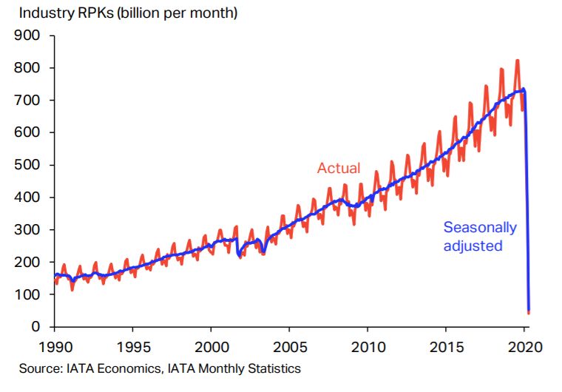According to a study conducted by the IATA (International Air Transport Association), it has been depicted that passenger air transport which is calculated as revenue passenger kilometre (means one passenger has travelled for one kilometre, used as a metric) was down 90% as per April 2020 but in August 2020 it was 75% as its lowest. (IATA, 2020). Passenger air travel was not the only aspect affected but freight as well. The figure below denotes the slowly upward then swift decline trend in revenue passenger kilometre.

Figure : IATA Statistics

Through mid – 2020, airline companies have taken on few uncertainties as to how they are meant to cope with the pandemic. These include taking on precautionary health measures and adjusting with new international travel restrictions. Airline companies have noticed an increase in their operating costs for passenger traveling flights since both airports and airline staff need to continuously disinfect passenger seats, provide temperature checks, testing etc. Another issue is understanding international travel restrictions, where airline companies have to be updated on every rule or regulation being posed by different countries/governments. This can be quite difficult in terms of recovery for these companies. (OECD, 2020)

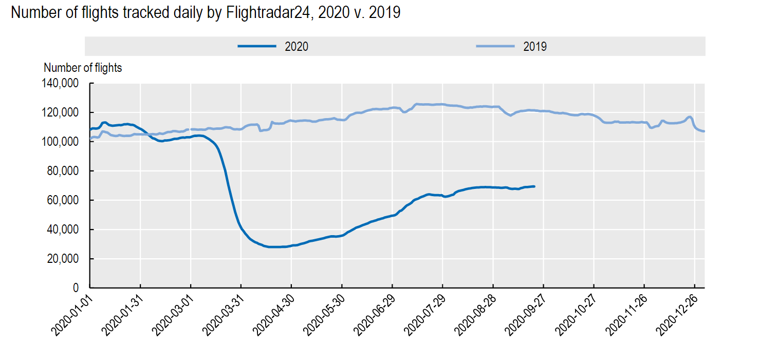Furthermore, another topic which could be further examined on would be the number of commercial flights active. According to statistics provided by FlightRadar24, the number of flights tracked daily is compared from 2019-2020. (OECD, 2020). The data shows an upward trend of 100,000+ flights in 2019 whereas for 2020, the decline in flights is quite drastic from March onward then slowly rises up as the months go by. The graph below shows an accurate representation of commercial flights tracked across the world, which is not excluding cargo or charter flights (unscheduled flights).

Figure : FlightRadar24 Statistics

## Analysis of Existing Projects

|  |  |
| --- | --- |
| **Articles** | **Aim/Objective** |
| **(Nakamura and Managi, 2020).** | This research paper which was published on July 1st 2020 shows a basic understanding of how COVID-19 has spread across the globe through air travel. This paper shows a good visualisation and similarity as to how this project is to achieve its goals. The data visualizations specify various heat zones, exportation of the virus, travel flows etc. |
| **(Kuan, 2021).** | This is a solely data visualization study designed by a data engineer using the data from the OpenSky Network, which is the same dataset being used for this project. The article consists of a general explanation of how the air industry has been affected. The visualizations convey a specific meaning to different aspects of the dataset such as cargo, airport count, flights etc. |
| **Strohmeier, M., Olive, X., Lübbe, J., Schäfer, M. and Lenders, V. (2020).** | This is an advanced data research paper published on the Earth System Science Data website where it shows a deeper insight on the dataset of the OpenSky Network. The research paper highlights background, data cleaning, methods of data collection, authors etc. The visualizations are mostly line graphs understanding various flight types, airports and travel paths (latitude and longitude). |

Table : Existing Projects

Although there were a few projects and research papers analysing COVID-19 and air travel, it was still not as vast as that of other projects/issues. Through viewing other data science reports, it can be beneficial to have a clear idea of how the data should be analysed and worked on. These were a few of the projects/research papers created by different data scientists and researchers around the world:

# Requirements

Hardware Requirements**:**

Understanding the use of hardware and its concepts are key to a successful project, without having good hardware, no task or project development can begin. Most hardware would consist of a good laptop/PC (with a mouse and keyboard) having a good internet connection for research/learning purposes.

Software Requirements**:**

1. Kaggle – This will be the hub of where all sorts of visualisation, analytics and machine learning use cases will be present. Through reviewing other users work such as data science notebooks, this will help in providing a good idea of what is to be expected and achieved.
2. Visual Studio Code – This will be the Integrated Development Environment (IDE) of choice. The main reason for why this IDE was chosen is due to the fact that Git and Python is well integrated for the right use case.
3. Jupyter Notebook – This is an interactive software mainly used for running code simultaneously and showing the results, also known as live code. This will be a great help in running large chunks of code at one time.
4. Microsoft Excel – The application for the task of data cleaning is most suited towards Excel. The software has a lot of functionality towards filtering and sorting unwanted data from the useful data.
5. Microsoft Word – For the main report and documentation on the work progress, Word will be used. This will help format the work and make it readable for anyone to understand the problem statement and solution.
6. Weka – For machine learning models Weka has a lot of algorithms to suit all types of needs. A selected algorithm will be used on the cleaned dataset and display understandable results.
7. Trello – This application will handle all the project tasks and help in categorizing all work-related information or details. (Trello, 2020)

# System Analysis & Design

For a better understanding of how the data visualizations should be created, wireframes were created for this sole reason. A wireframe is a conceptual design of what the final product should look like. (Balsamiq. Rapid, Effective and Fun Wireframing Software | Balsamiq, 2021). This can change as the project goes on but the base idea will remain the same. Wireframing is a process of creating a basic outline or design to help a client or user understand where each aspect should be. The uses for wireframes are quite heavy through UX designers and software developers. This helps them understand where each element should be made. (Hannah, 2021)

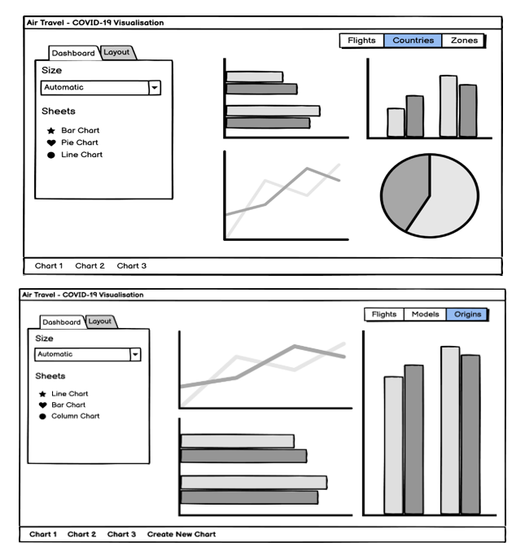The following wireframes show a clear structure of data visualization dashboards:

Figure : Wireframes

## Project Management Methodologies

A project management methodology is considered as a set of rules and processes for managing a project and its required tasks. The term ‘project management’ is another way of saying a system is needed before starting the project. (Westland, 2021). Most methodologies are chosen based on how a team is able to work and communicate. A few methodologies are Waterfall, Kanban, Scrum, Agile, Scrumban, Lean etc. These are a few project methodologies which were considered for this project. These are as follows:

Table : Project Methodologies

|  |  |  |
| --- | --- | --- |
| **PROJECT METHODOLOGIES** | **PROS** | **CONS** |
| **Waterfall Methodology** | End goal is defined.  Project is consistent.  Extensive documentation. | Project cannot be modified.  Requirements not finalized.  Continuous testing is required. |
| **Kanban Methodology** | Great visualisation of goals.  Easy to read project updates.  Task assignment is quick. | Too many stages or boards.  Can be overwhelming at first glance. |
| **Agile Methodology** | Project can be modified.  Work progress is quick. | Project cannot be modified midway.  Strict deadlines and mindset. |

Through weighing the pros and cons of each project management workflow, the Kanban method was chosen as it met the needs of these project tasks.

Kanban Workflow**:**

Kanban methodology will help increase output efficiency and quality of the deliverable produced at each iteration. Kanban has many advantages in terms of project task completion, one such advantage can be creating a visualization of what the project tasks are to be completed and what deadlines are set for each of them. This methodology is quite similar to Lean and Scrum principles. It focuses on collaboration and self-managing team. Kanban is also known to be quite flexible for the project tasks as tasks can be added, edited and removed accordingly. For the report, the software called Trello will be used which follows the Kanban methodology. (Project Management Methodologies - Everything You Need To Know, 2020)

Trello is a project management application which is part of the Atlassian suite of applications. It focuses on bringing flexibility and increased productivity for projects of all types. Through the use of Trello, project organization is superior in splitting the tasks of the board into three phases; To Do, Ongoing & Completed. As a plus point, there will be automation of tasks between each phase of the board meaning once a task is completed, it will automatically change it to the completed phase. (Trello, 2020)

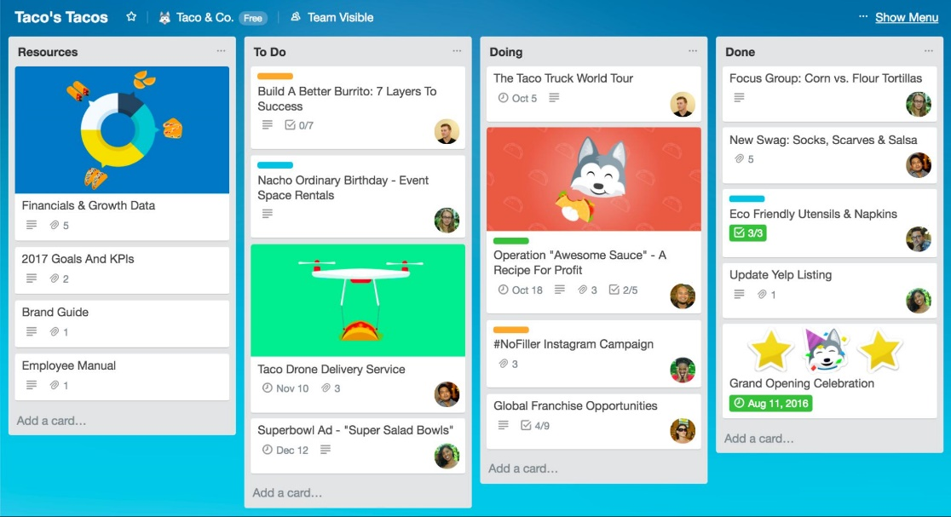

Figure : Trello

# References

Chellaney, B., 2020. *The World Health Organization Must Stop Covering Up China’S Mistakes*. [online] MarketWatch. Available at: <https://www.marketwatch.com/story/the-who-has-a-big-china-problem-2020-04-22>.

Nakamura, H. and Managi, S., 2020. Airport risk of importation and exportation of the COVID-19 pandemic. *Transport Policy*, 96, pp.40-47.

Olive, X., Strohmeier, M. and Lübbe, J., 2020. *Crowdsourced Air Traffic Data From The Opensky Network 2020*. [online] Zenodo. Available at: <https://zenodo.org/record/4299837#.X8u75mgzY2x>.

Strohmeier, M., Olive, X., Lübbe, J., Schäfer, M. and Lenders, V., 2020. [online] Essd.copernicus.org. Available at: <https://essd.copernicus.org/preprints/essd-2020-223/essd-2020-223.pdf>.

Teamwork.com. 2020. *Project Management Methodologies - Everything You Need To Know*. [online] Available at: <https://www.teamwork.com/project-management-guide/project-management-methodologies/>.

Trello.com. 2020. *Trello*. [online] Available at: <https://trello.com/en>.

Kuan, C., 2021. *Visualization Of Air Traffic During Covid-19 Pandemic*. [online] Medium. Available at: <https://towardsdatascience.com/visualization-of-air-traffic-during-covid-19-pandemic-c5941b049401>.

Westland, J., 2021. *Project Management Methodologies - An Overview*. [online] ProjectManager.com. Available at: <https://www.projectmanager.com/blog/project-management-methodology>.

Aravindan, P., 2021. *Design Tools For Data Visualization*. [online] Medium. Available at: <https://medium.com/sketch-app-sources/design-tools-for-data-visualization-f7d040f82497>.

Balsamiq.com. 2021. *Balsamiq. Rapid, Effective And Fun Wireframing Software | Balsamiq*. [online] Available at: <https://balsamiq.com/>.

Hannah, J., 2021. *What Exactly Is Wireframing? A Comprehensive Guide*. [online] Careerfoundry.com. Available at: <https://careerfoundry.com/en/blog/ux-design/what-is-a-wireframe-guide/>.

Icao.int. 2021. *Economic Impacts Of COVID-19 On Civil Aviation*. [online] Available at: <https://www.icao.int/sustainability/Pages/Economic-Impacts-of-COVID-19.aspx>.

Oecd.org. 2021. [online] Available at: <http://www.oecd.org/coronavirus/policy-responses/covid-19-and-the-aviation-industry-impact-and-policy-responses-26d521c1/>.

Iata.org. 2021. [online] Available at: <https://www.iata.org/en/iata-repository/publications/economic-reports/air-passenger-monthly-analysis---apr-20202/>.